John Carroll
Jcc0044/902521946

Computer Architecture
Homework 8
Theme: Input-Output

- What are the differences between Programmed I/O, Interrupt-Driven I/O and DMA?
Programmed I/O
Programmed I/O (PIO) refers to data transfers initiated by a CPU under driver software control to access registers or memory on a device.
The CPU issues a command then waits for I/O operations to be complete. As the CPU is faster than the I/O module, the problem with programmed I/O is that the CPU has to wait a long time for the I/O module of concern to be ready for either reception or transmission of data. The CPU, while waiting, must repeatedly check the status of the I/O module, and this process is known as Polling. As a result, the level of the performance of the entire system is severely degraded.
Programmed I/O basically works in these ways:
- CPU requests I/O operation
- I/O module performs operation
- I/O module sets status bits
- CPU checks status bits periodically
- I/O module does not inform CPU directly
- I/O module does not interrupt CPU
- CPU may wait or come back later
Interrupt
The CPU issues commands to the I/O module then proceeds with its normal work until interrupted by I/O device on completion of its work.
For input, the device interrupts the CPU when new data has arrived and is ready to be retrieved by the system processor. The actual actions to perform depend on whether the device uses I/O ports, memory mapping.
For output, the device delivers an interrupt either when it is ready to accept new data or to acknowledge a successful data transfer. Memory-mapped and DMA-capable devices usually generate interrupts to tell the system they are done with the buffer.
Although Interrupt relieves the CPU of having to wait for the devices, but it is still inefficient in data transfer of large amount because the CPU has to transfer the data word by word between I/O module and memory.
Below are the basic operations of Interrupt:
- CPU issues read command
- I/O module gets data from peripheral whilst CPU does other work
- I/O module interrupts CPU
- CPU requests data
- I/O module transfers data
Direct Memory Access (DMA)
Direct Memory Access (DMA) means CPU grants I/O module authority to read from or write to memory without involvement. DMA module controls exchange of data between main memory and the I/O device. Because of DMA device can transfer data directly to and from memory, rather than using the CPU as an intermediary, and can thus relieve congestion on the bus. CPU is only involved at the beginning and end of the transfer and interrupted only after entire block has been transferred.
Direct Memory Access needs a special hardware called DMA controller (DMAC) that manages the data transfers and arbitrates access to the system bus. The controllers are programmed with source and destination pointers (where to read/write the data), counters to track the number of transferred bytes, and settings, which includes I/O and memory types, interrupts and states for the CPU cycles.
DMA increases system concurrency by allowing the CPU to perform tasks while the DMA system transfers data via the system and memory busses. Hardware design is complicated because the DMA controller must be integrated into the system, and the system must allow the DMA controller to be a bus master. Cycle stealing may also be necessary to allow the CPU and DMA controller to share use of the memory bus.

- Discuss the different ways of mapping I/O addresses to the processor address space.
When the processor, main memory, and I/O share a common bus, two modes of addressing are possible: memory mapped and isolated. With memory-mapped I/O, there is a single address space for memory locations and I/O devices. The proc- essor treats the status and data registers of I/O modules as memory locations and uses the same machine instructions to access both memory and I/O devices. So, for example, with 10 address lines, a combined total of 210 = 1024 memory locations and I/O addresses can be supported, in any combination.
With memory-mapped I/O, a single read line and a single write line are needed on the bus. Alternatively, the bus may be equipped with memory read and write plus input and output command lines. Now, the command line specifies whether the address refers to a memory location or an I/O device. The full range of addresses may be available for both. Again, with 10 address lines, the system may now support both 1024 memory locations and 1024 I/O addresses. Because the address space for I/O is isolated from that for memory, this is referred to as isolated I/O.
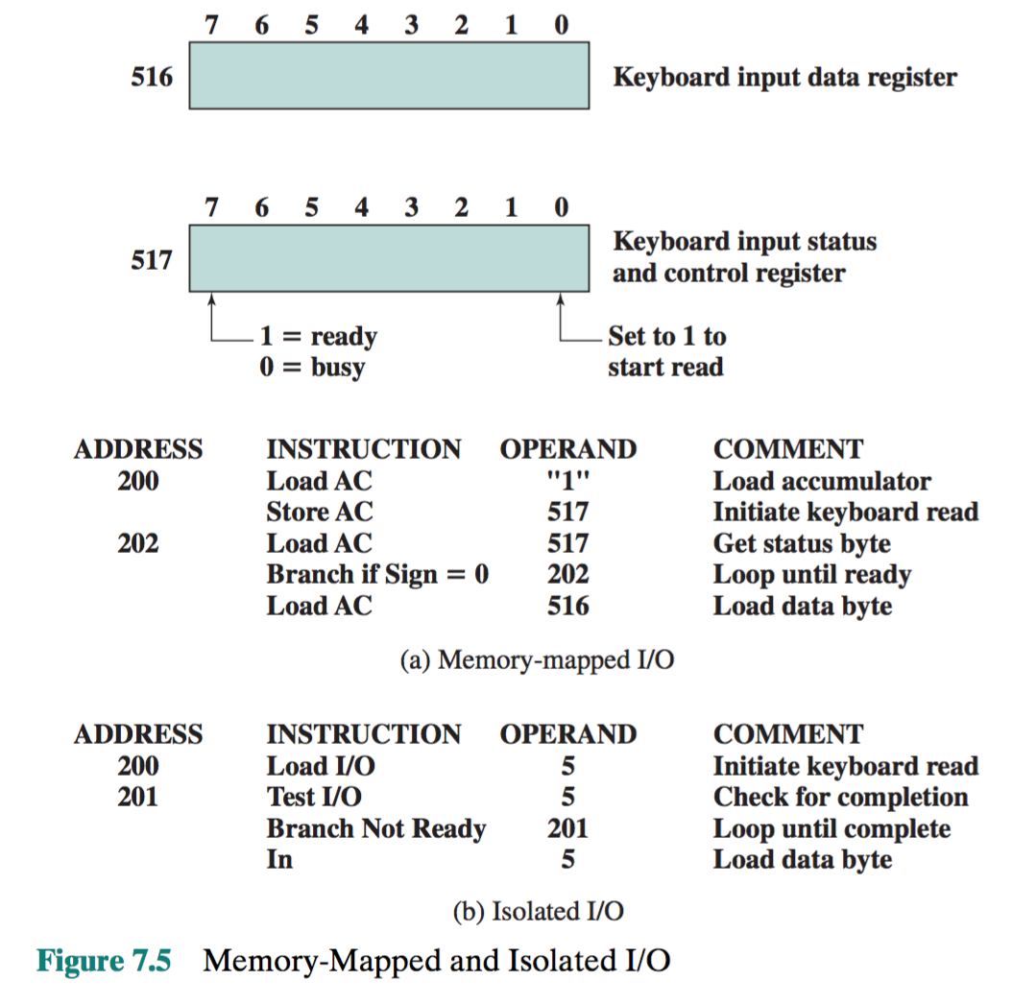
Figure 7.5 contrasts these two programmed I/O techniques. Figure 7.5a shows how the interface for a simple input device such as a terminal keyboard might appear to a programmer using memory-mapped I/O. Assume a 10-bit address, with a 512- bit memory (locations 0–511) and up to 512 I/O addresses (locations 512–1023). Two addresses are dedicated to keyboard input from a particular terminal. Address 516 refers to the data register and address 517 refers to the status register, which also functions as a control register for receiving processor commands. The program shown will read 1 byte of data from the keyboard into an accumulator register in the processor. Note that the processor loops until the data byte is available.
The I/O ports are accessible only by special I/O commands, which activate the I/O command lines on the bus. For most types of processors, there is a relatively large set of different instruc- tions for referencing memory. If isolated I/O is used, there are only a few I/O instructions. Thus, an advantage of memory-mapped I/O is that this large repertoire of instructions can be used, allowing more efficient programming. A disadvantage is that valuable memory address space is used up. Both memory-mapped and isolated I/O are in common use.

- A DMA module is transferring characters to memory using cycle stealing, from a device transmitting at 38400 bps. The processor is fetching instructions at the rate of 4 million instructions per second (4 MIPS). By how much will the processor be slowed down due to the DMA activity?
Ans: 38400 bps = 38400/8 = 4800 char per sec (by assuming 8 bit per char or byte).
Slow down = (4800/ (4 × 10⁶)) × 100
= 0.12%

- A computer consists of a processor and an I/O device D connected to main memory M via a shared bus with a data bus width of one word. The processor can execute a max of 3 MIPS. An average instruction requires 5 machine cycles, 3 of which use the memory bus. A memory read/write operation uses 1 m/c cycle. Suppose that the processor is continuously executing “background” programs that require 96% of the instruction rate but not any I/O instructions. Assume that one processor cycle equals one bus cycle. Now suppose the I/O device is used to transfer very large amounts of data between M and D.
  - If programmed I/O is used and each one word transfer requires the processor to execute 3 instructions, estimate the max I/O data transfer rate in words/sec possible through D.
Maximum using programmed I/O: 4% * 3x10^6 = 120000 instructions/second, so take 120000/3 and you get 40000 words/second

  - Estimate the same rate if DMA is used.
Maximum throughput using DMA is using all the cycles not doing instructions, which is 3,000,000 * ((.04 * 5) + (.96 * 2))

- When a device interrupt occurs, discuss different ways the processor can determine which device issued the interrupt. When a DMA module takes control of the bus, and while it retains control of the bus, what does the processor do?
First, the processor must determine which interrupt occurred. On simple hardware setups, you may already know this just by which interrupt handler was called. On more complex hardware, you may have to read status registers in the interrupt controller.
Second, the processor has to look up which devices are capable of asserting that interrupt. On simple hardware, generally there is only one device that can trigger each interrupt and this is determined by the way the device is wired. On more complex devices, this may be determined by software and the processor may have to consult tables that were created during the boot process.
Third, the processor must determine which of those devices actually asserted the interrupt (if there's more than one). The driver for each device, which generally just asks the device if it triggered an interrupt, typically does this. Most devices have status registers that either directly tell you whether it caused an interrupt or tell you whether the device needs service, which was the point of the interrupt anyway.

If you have a 'real' DMA, the DMA is a peripheral, which does not interact or interfere with any other part of the microprocessor or microcontroller, including the main bus. All the ARM processors I have worked with are like this.
Some low-power or low-cost microprocessors and microcontrollers have a feature, which they also call a DMA, but which is occupies the bus and prevents the processor core from doing anything else. I believe that these have been implemented by various different methods, and even though they do prevent any other core activity, these DMAs are still useful. Some small, low power uC I have worked with have this.
Either way, the DMA is useful because they can transfer data much more quickly than is possible in software, especially for large collections of data, such as arrays of ADC samples. The DMA is also useful because you can pre-configure it, and allow for hardware or software triggering, which is great for using on quick, time sensitive, periodic, or unpredictable events.

- Discuss FireWire, SCSI, Thunderbolt, Infiniband, PCI Express, SATA, Ethernet, and WiFi. The discussion should be no more than one page.
FireWire is Apple Computer's version of a standard, IEEE 1394, High Performance Serial Bus, for connecting devices to your personal computer. FireWire provides a single plug-and-socket connection on which up to 63 devices can be attached with data transfer speeds up to 400 Mbps (megabits per second). The standard describes a serial bus or pathway between one or more peripheral devices and your computer's microprocessor. Many peripheral devices now come equipped to meet IEEE 1394.
Thunderbolt, developed under the name Light Peak, is the brand name of a hardware interface that allows the connection of external peripherals to a computer. Thunderbolt 1 and 2 use the same connector as Mini DisplayPort(MDP), while Thunderbolt 3 will use USB Type-C. It was first sold as part of a consumer product on February 24, 2011. Thunderbolt combines PCI Express (PCIe) and DisplayPort (DP) into one serial signal, and additionally provides DC power, all in one cable. Up to six peripherals may be supported by one connector through various topologies.
The Small Computer System Interface (SCSI) is a set of parallel interface standards developed by the American National Standards Institute (ANSI) for attaching printers, disk drives, scanners and other peripherals to computers. SCSI (pronounced "skuzzy") is supported by all major operating systems.
InfiniBand (abbreviated IB), a computer-networking communications standard used in high-performance computing, features very high throughput and very low latency. It is used for data interconnect both among and within computers. InfiniBand is also utilized as either a direct, or switched interconnect between servers and storage systems, as well as an interconnect between storage systems.
PCI Express (Peripheral Component Interconnect Express), officially abbreviated as PCIe, is a high-speed serial computer expansion bus standard designed to replace the older PCI, PCI-X, and AGP bus standards. PCIe has numerous improvements over the older standards, including higher maximum system bus throughput, lower I/O pin count and smaller physical footprint, better performance scaling for bus devices, a more detailed error detection and reporting mechanism (Advanced Error Reporting, AER^{[1]}), and native hot-plug functionality. More recent revisions of the PCIe standard provide hardware support for I/O virtualization. The PCI Express electrical interface is also used in a variety of other standards, most notably in ExpressCard as a laptopexpansion card interface, and in SATA Express as a computer storage interface.
Serial ATA (SATA, abbreviated from Serial AT Attachment^{[2]}) is a computer bus interface that connects host bus adapters tomass storage devices such as hard disk drives and optical drives. Serial ATA succeeded the older Parallel ATA (PATA) standard,^{[a]} offering several advantages over the older interface: reduced cable size and cost (seven conductors instead of 40 or 80), native hot swapping, faster data transfer through higher signaling rates, and more efficient transfer through an (optional) I/Oqueuing protocol.
Ethernet is the most widely installed local area network (LAN) technology. Ethernet is a link layer protocol in the TCP/IP stack, describing how networked devices can format data for transmission to other network devices on the same network segment, and how to put that data out on the network connection. It touches both Layer 1 (the physical layer) and Layer 2 (the data link layer) on the OSI network protocol model. Ethernet defines two units of transmission, packet and frame. The frame includes not just the "payload" of data being transmitted but also addressing information identifying the physical "Media Access Control" (MAC) addresses of both sender and receiver, VLAN tagging and quality of service information, and error-correction information to detect problems in transmission. Each frame is wrapped in a packet, which affixes several bytes of information used in establishing the connection and marking where the frame starts.
Wi-Fi is the name of a popular wireless networking technology that uses radio waves to provide wireless high-speed Internet andnetwork connections. A common misconception is that the term Wi-Fi is short for "wireless fidelity," however this is not the case. Wi-Fi is simply a trademarked phrase that means IEEE 802.11x.

